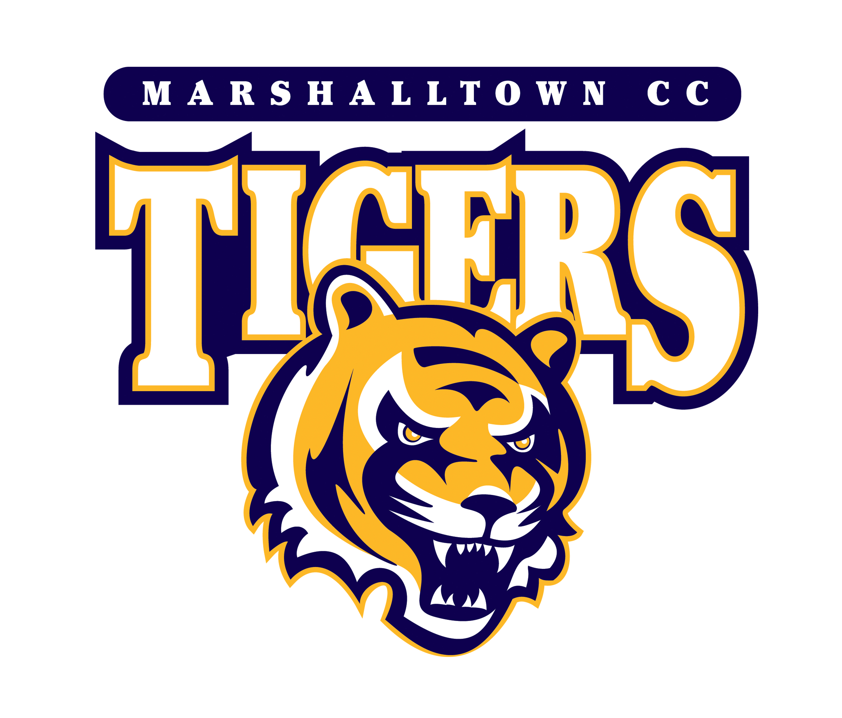
2015-16 Marshalltown Community College Men’s Basketball Roster
No. Name Pos. Yr. Ht. Wt. Hometown/High School
1 Danny Mozee G Fr. 6-0 150 Louisville, KY / Louisville Male
2 Tyler Miller G So. 6-4 185 Louisville, KY / 22ft Academy
3 Nick Cross G Fr. 6-4 190 Beverly, MA / Beverly
4 Souf Mensah G Fr. 6-2 210 Nantes, France / CCI
5 Denzel Ubiaro G Fr. 6-3 185 London, England / City of London Academy
11 Kali Arrington G Fr. 6-2 170 Davenport, IA / Davenport
20 Jamil Maddred F Fr. 6-5 190 Camden, NJ / Camden
21 Amir Maddred F So. 6-7 240 Camden, NJ / Camden
23 Vincent Lasley F So. 6-5 210 Tama, IA / South Tama
24 Christal Malalu F So. 6-8 245 Eindhoven, Netherlands / Koning Willem 1
30 Guilherme Verardo G So. 6-6 200 Sao Paulo, Brazil / Esporte Clube Pinheiros
32 Jonas Perkis F Fr. 6-9 240 Trondheim, Norway / Charlottenlund VGS
33 Reggie Gradwell F Fr. 6-7 185 Marshalltown, IA / West Marshall
41 Paulius Sakinis F So. 6-8 235 Klaipeda, Lithuania / Lourdes Central Catholic

Head coach: Brynjar Brynjarsson (11th Year)
Assistant Coaches: Ron Ginapp (5th Year), Michael Appel (2nd Year), Vesteinn Sveinsson (2nd Year)
Athletic Trainer: Toby Nicholson

